Science TEKS: 3.11, 4.6, 5.3, 5.1, 5.2, 5.4, 5.5, 5.6 Name_______________________
Math TEKS: 5.11, 5.14, 5.15

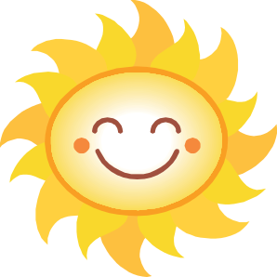
Did you know? Cumulonimbus clouds can hold up to half a million tons of water!

Lesson Two: Physical Properties of the Atmosphere

Overview. Today, you will take your first measurements outside! You will be measuring the amount of ozone in the air, the humidity, the wind direction, the air temperature, and the temperature of some surfaces. You will also be able to observe the types of clouds that are in the sky. You will take these measurements at both the beginning and at the end of the class.
You will also be learning about the layers of the atmosphere and about two physical properties of the atmosphere: temperature and wind.

Which instrument are you most excited to use today?

Label the layers of the atmosphere.
(Note: The actual atmosphere is very thin compared to Earth. It is drawn big here so you can label it.)
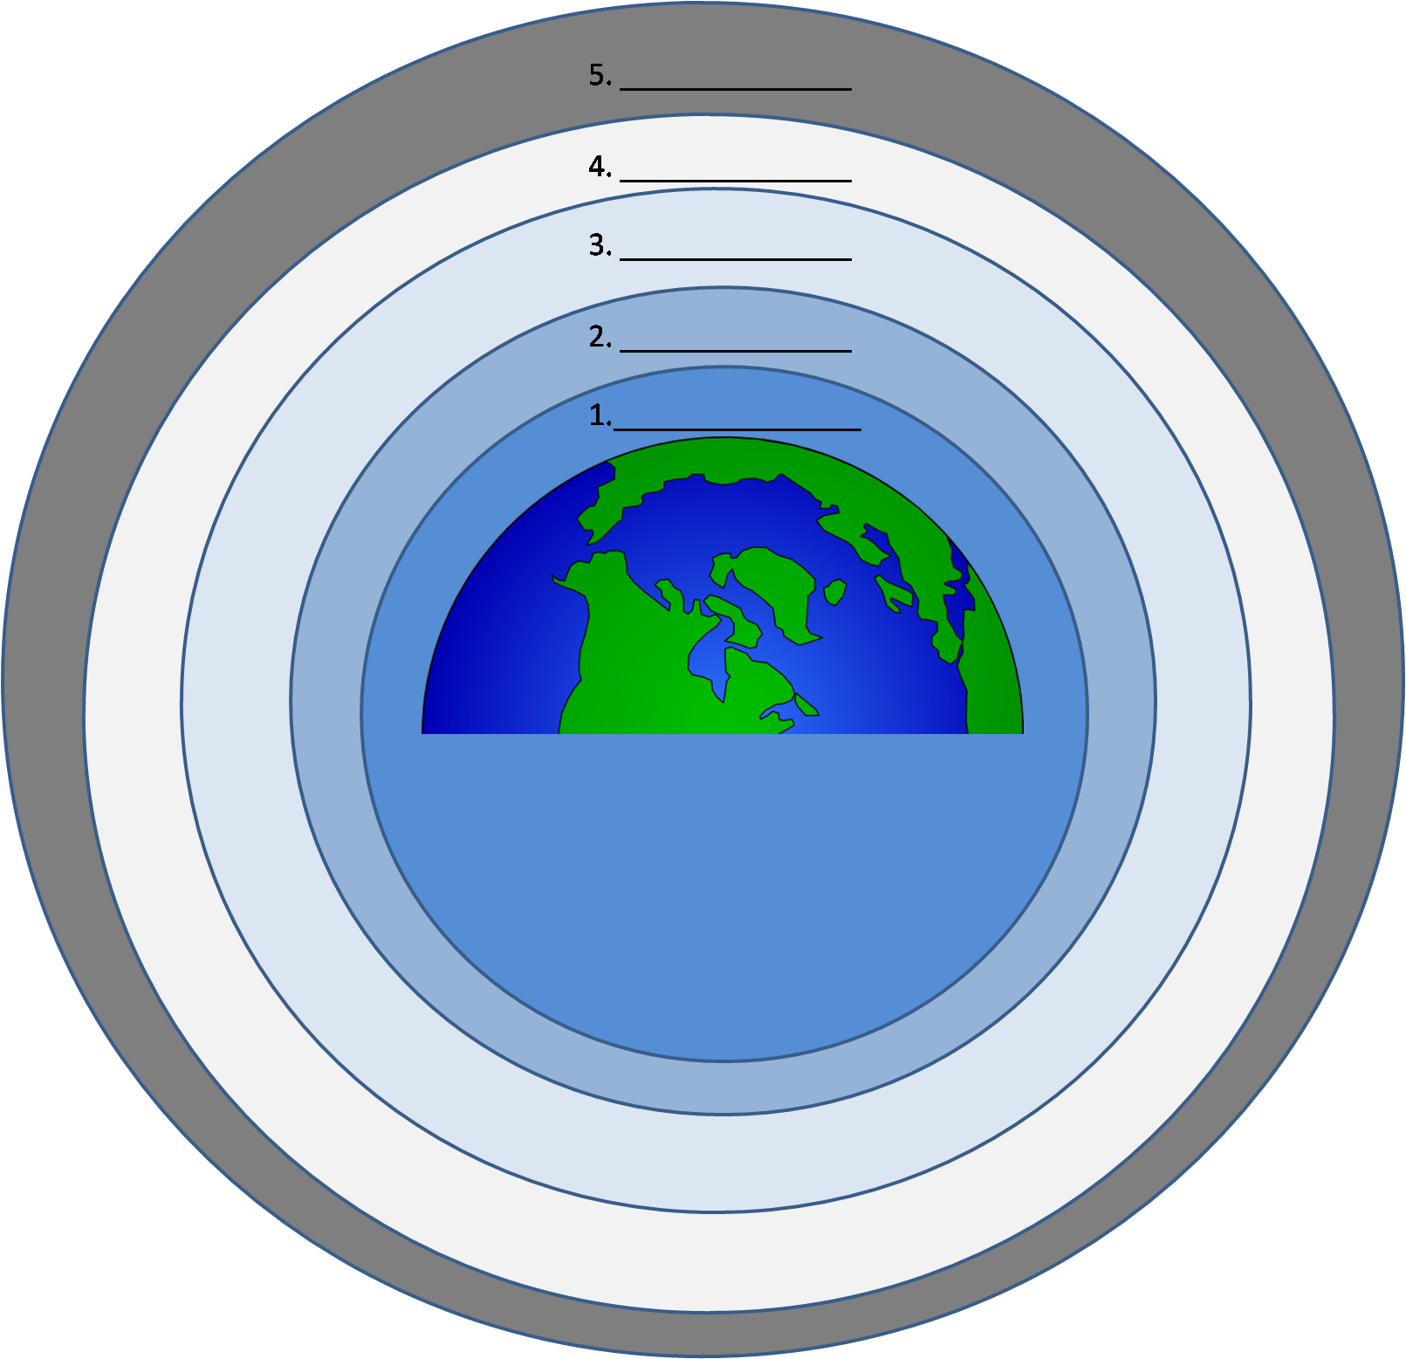
What is something that you might find in each layer?

1.
2.
3.
4.
5.

Temperature
Which instruments do we use to measure temperature?

What is an urban heat island? What causes it to occur?

Wind
Which instrument do we use to measure wind direction?

What causes the wind to blow?
You have begun measuring surface temperature and air temperature with your GLOBE measurements.

Which instruments did you use to measure surface temperature and air temperature?
______________________________________________________________________________

What types of objects did you measure for surface temperature?
_______________________________________ ______________________________________________________________________________

Which object had the warmest surface temperature? Why do you think that object was warmer than the other objects?
_______________________________________ _____________________________________________________________________________________________________________________

